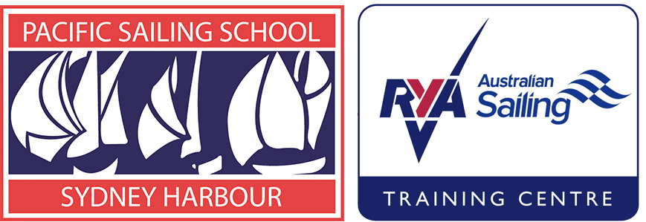
FAST
FURIOUS
so MUCH FUN!

CYCA WINTER SERIES 2021

Racing starts April 18

Join us for the popular Winter Series for a great introduction to crewing.

It involves training sessions, rules & social evenings, 13 Sunday races on Sydney Harbour, with crewing-roles rotating.

Join us every Sunday morning for a freshly cooked breakfast and piping hot coffee from the CYCA Club volunteers, before heading onto the water.

Winter sailing on the Harbour is exciting and great fun afterwards at the Clubhouse. An average of 140 Spinnaker boats compete each Sunday in this iconic series.

Our aim? To get you top crew spots.

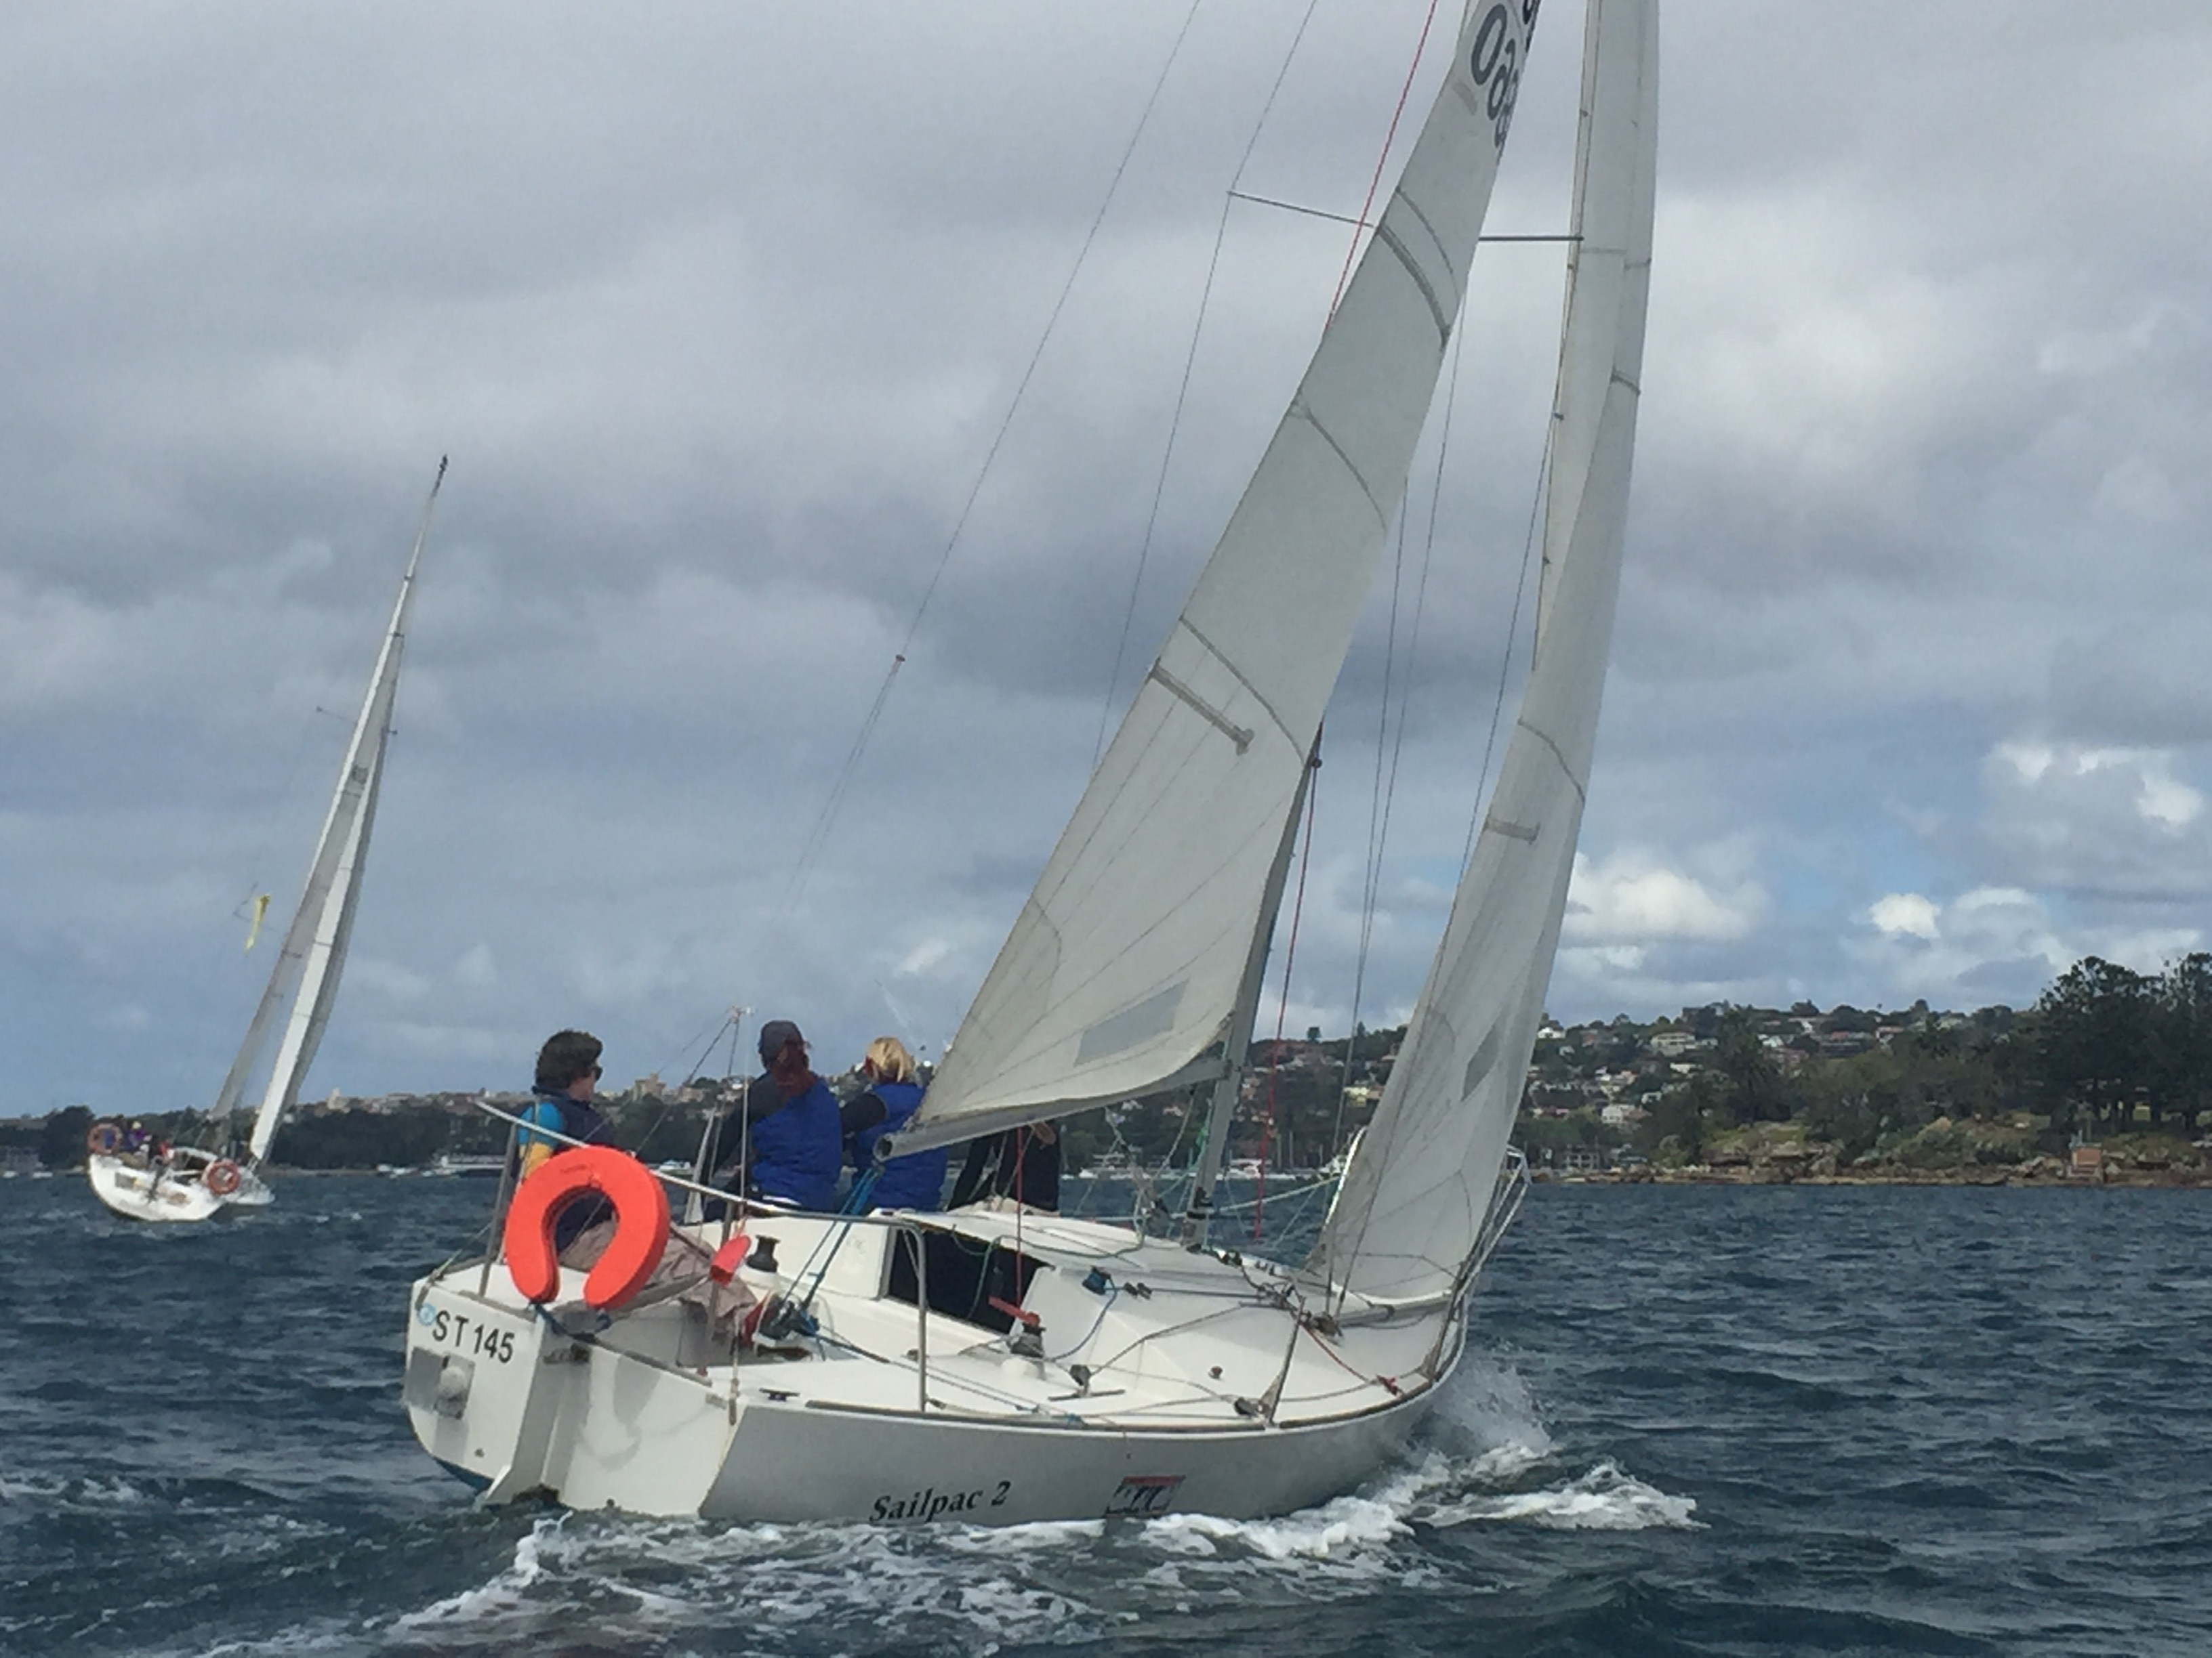

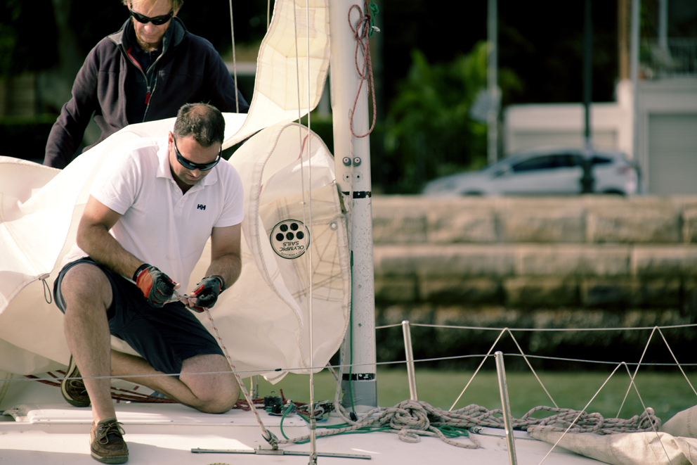
THE LOW DOWN:

- Training sessions
- Ten points score races
- Three women’s skipper races
- Racing rules social nights
- Prize giving dinner
- Join us racing Sailpac & Bandit
- Top crew introductions
- Make lifelong friends
- Limited spaces
- Winter sailing is the best

Pacific Sailing School Pty Ltd. At the:
Cruising Yacht Club of Australia, New Beach Road,
Rushcutters Bay 2011 NSW Australia
info@pacificsailingschool.com.au
WE TEACH
SAILING SAFETY
& FUN!

Phone +61 2 9326 2399
Within Australia 02 9326 2399
PO Box 249, Edgecliff 2027
NSW Australia ABN 63 002 378 618
www.pacificsailingschool.com.au

Join us
Two training sessions
Ten - point score race days
Three - Women’s points score races
Racing Rules and social evenings
Prize giving dinner.

Training sessions  0930 to 1230  1300 to 1600  Saturday May 3  Saturday June 5  Others as required | Race Days – Sundays 0830 to late  April 18 (Women’s Series R1)  April 25 - Race 1  May 2 - Race 2  May 9 - Race 3  May 16 - Race 4  May 23 - Race 5  May 30 - Race 6 | June 6 - Race 7  June 13 - (Women’s Series R2)  June 20 - Race 8  June 27 - Race 9  July 4 - Race 10  July 11 - (Women’s Series R3)
*Book full series and the Women’s Series Races - save 20% | $200 per day | 13 Races with training days & social evenings $2,600 (*must book minimum 10 races)
*Book 7 races save 10% | $225 per day | *7 races with training days & social evenings $1575
Fee - per single race | $250 per day | Available standby basis only
Tactic, Racing Rules & social evenings | April 20 & August 24. | Prize Giving Dinner  Friday July 23
Information and Booking Conditions:

- Allocation of boats is on a first come first serve basis.
- Stand by, may be available at cost of $250 per day plus insurance if required
- *Book additional races, fee for extra days on a pro-rata basis.
- PSS reserves the right to cancel racing and/or training days due to weather and/or safety concerns. In such event an alternate sailing day will be scheduled
- Non-attendance on sailing and training days will not be rescheduled or refunded.
- Race training sessions recommended
- Key crew positions allocated to Spinnaker course graduates
- Prize Giving Dinner Friday July 23
International J24
- Sailpac 11 – Skipper Wendy Tuck
- Bandit – Skipper TBC
The Plan:
- Breakfast & briefing with the skipper from 0830
- Training and boat set up 0930 to 1030
- Race 1100 to 1500 and back at the Club latest 1600 for debriefing.
- Might get wet and get a few bruises
- Sooo much Fun!

To be competent crew - book today!

